We are looking for a website developed using WordPress using some commercial theme like Elementor Pro.

Below are the few requirements. It's not the entire website I am just highlighting main features. I am adding the screen captures to explain.

As you see in the below picture you need to have a main menu, and side nav and

when the user clicks on a frame type the image will get updated. So the image portion should be a custom component and basically you have to create templates for the website and marketing department will add the content later. so for example the marketing department will add a new frame type and they don't need to be dependent on a developer.

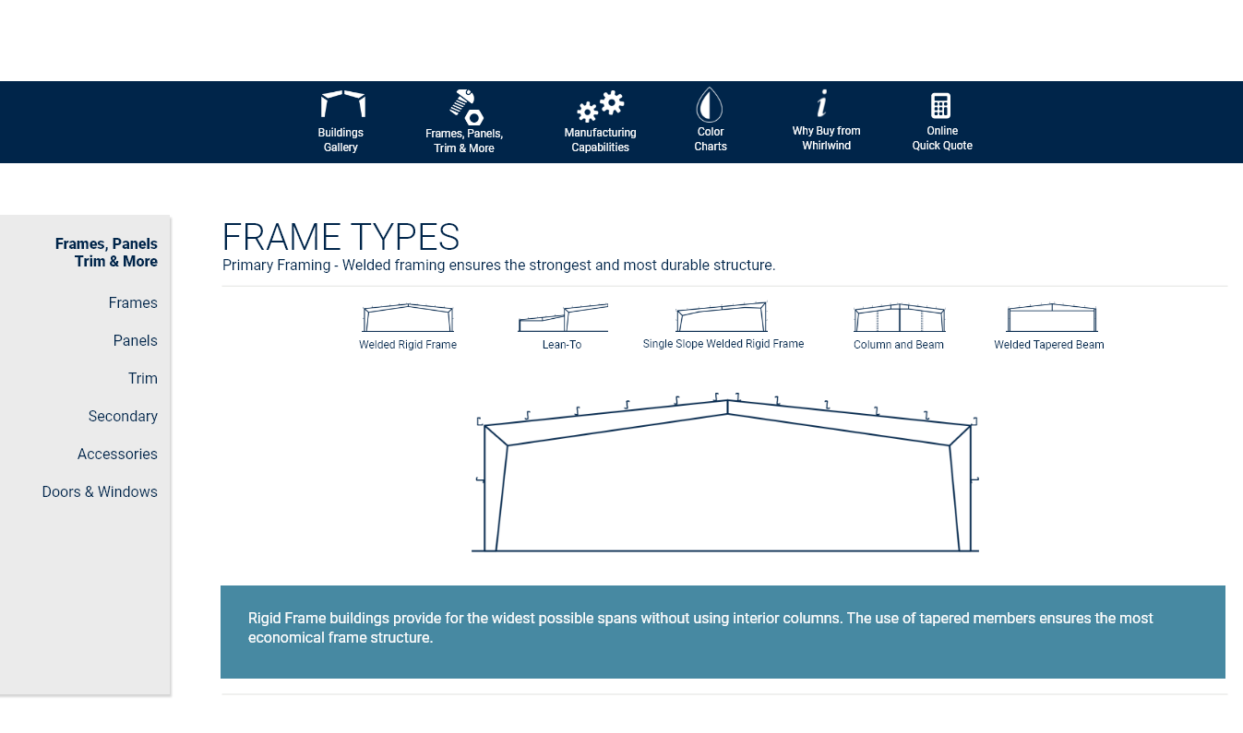

As the user scrolls on the page new content will be loaded and the menu on the left side should be bold depending on the section where the user is. And here if the user clicks on Cor-Span the center image will get updated and so on.

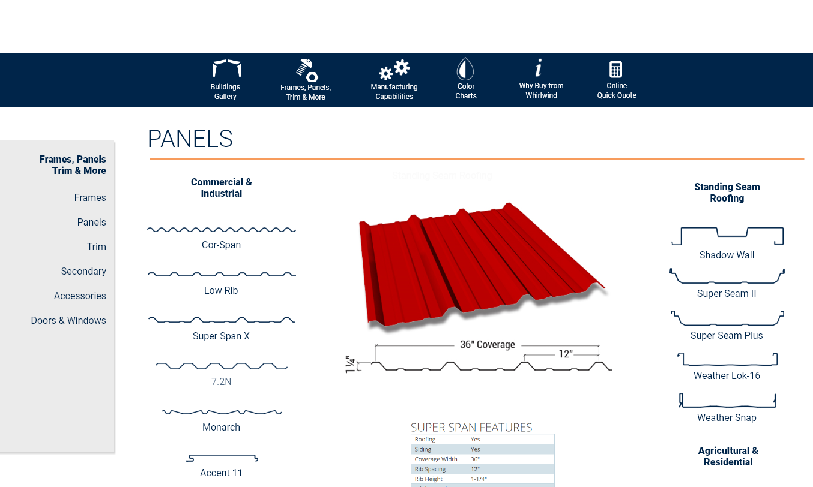

Same here when they select different trim types the center image will get updated.

